
Highfield Nursery School
SEND Information Report 2026-2027

This report is to support parents with important information relevant to the needs of their child. The report explains how Highfield works with children, parents, the Local Authority and other professionals to ensure that children are supported in reaching their potential. This document is written in close reference to the 2015 SEND Code of Practice and should be considered alongside Highfield’s SEND Policy.

Our School Ethos
At Highfield we nurture every child to fulfil their potential and to become happy people and lifelong learners. We believe in valuing and respecting everyone in a welcoming, accessible and inclusive environment. We pride ourselves on our excellent record for SEND inclusion and provision.
At Highfield we feel strongly that all young children have the right to high quality early learning and teaching.
We are very keen to work in partnership with parents/carers, outside agencies such as speech therapists, doctors and educational psychologists in order that individual children may progress well. Some children come to Highfield with already identified special needs. Some children are identified whilst at Highfield. The school SEND Coordinator (SENDCo) and staff work closely with parents if any concerns about a child’s development are identified.
Our SEND Staff
The SENDCo is Denise Lewis. Mrs Lewis works closely with Sarah Pearce and Lorraine Hale who oversee the implementation of SEND support in each classroom.
We also have trained practitioners offering DMP (Developmental Movement Play) Theraplay and Speech and Language support.
If you would like to contact Mrslewis, please call school on 01473 742534 or email admin@highfield.suffolk.sch.uk and we will respond asap.
What is SEND?
A child has SEND (Special Educational Needs and Disabilities) if they have a learning difficulty or disability which calls for special educational provision to be made for him or her.
Special Educational Provision is ‘additional to’ or ‘different from’ provision for children of the same age.
Under the 2015 SEND Code of Practice there are 4 broad areas of need. These will be referred to in your child’s SEND Support Plan/Nurture Plan and EHC Plan.
- Communication and Interaction
e.g. speech and language/early communication difficulties and autistic Spectrum Disorder
2) Cognition and Learning
e.g. dyslexia or dyscalculia
3) Social, Emotional and Mental Health Difficulties
e.g. autism
4) Sensory and/or Physical Needs
e.g. visual impairments, hearing impairments, processing difficulties
Children often have needs that cut across all those areas and their needs may change over time eg a child with autism may have needs across all areas.
Identifying and assessing SEND at Highfield Nursery
At Highfield Nursery, we follow the ‘Graduated Approach’ to identifying and assessing children’s needs.
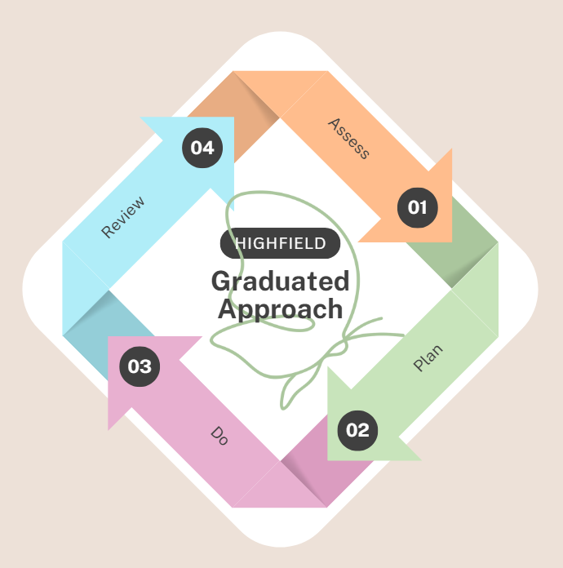
Accessibility Arrangements
We strive to ensure that the physical environment in and around our Nursery is accessible to all children.
We are fortunate that our school has just one level and there are no stairs, but we have ensured that all entrances have ramped wheelchair access. The classrooms are spacious and we are able to accommodate specialist chairs/tables etc.
Where needed, children with SEND have risk assessments of their access needs carried out and we purchase or borrow any equipment needed to remove an access barrier, for example, a raised chair or dietary modifications.
Classroom resources are made accessible by making personalised modifications as necessary, for example, proximity to whiteboards, PECS or visual timetables.
Physical activity planning is personalised to the needs of each child through liaison with specialist services, for example, DMP or Occupational Health targets.
Admissions Arrangements
Children are admitted to Highfield Nursery according to the school Admissions Policy. The school complies fully with the 2010 Equality Act in relation to the arrangements for the admission of children with additional needs. Where a child has a disability, the school will make reasonable adjustments and provide auxiliary aids or services to ensure that no disabled child is placed at a substantial disadvantage compared to other children.
Parents of children with disabilities are advised to speak to us prior to admission to discuss any reasonable adjustments required so that we can plan accordingly.
Equality of Opportunity
In practice we ensure that classroom and extracurricular activities encourage the participation of all children, including those with Special Educational Needs. Maximising resources and personnel within the school helps enable access to learning and participation by all children.
Parent Consultations
At Highfield we work closely with parents and carers and recognise that they have much to contribute to our support for children with SEND.
For children receiving SEND Support, we hold regular meetings with parents and discuss their child’s learning and development and any concerns. Parents are involved in contributing towards their child’s Nurture Plan. Targets are set and reviewed regularly.
Outside Agencies
We work closely with both educational and Health Professionals such as:
- Educational Psychology Service
- Occupational Therapy
- Speech and Language Therapy
- Physiotherapy Team
- Visual and Hearing Impairment Team
- Health Visitors/Specialist Health Visitors
We will ask for parental permission before any arrangements are made for outside agencies to come in and work with individual children. Once the feedback has been received, follow-up meetings are held with parents to share their advice and guidance.
The Local Offer
http://www.suffolklocaloffer.org.uk
All Local Authorities must publish a detailed summary of the services available to support children and young people with SEN and disabilities, named the ‘Local Offer’. This should cover services for education, health and social care.
It also includes information about:
- How a parent can request an assessment for an EHCP.
- Support to help children move between phases of education eg Early Years to Primary.
- Sources of information, advice and support in the local area relating to SEND, including forums for parents and carers and support groups.
- Arrangements for mediation and resolving disagreements in respect of SEND and provision.
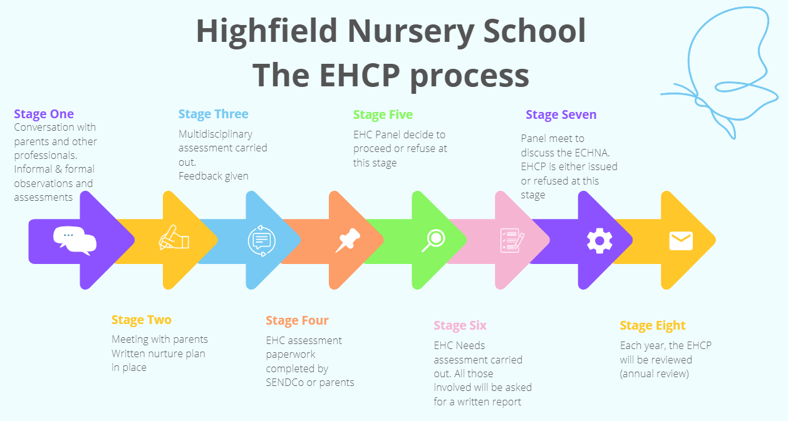

Complaints Procedures
We aim to work in close partnership with parents and families and regularly meet to review and audit each child’s nurture support. If parents are unhappy with the provision and wish to complain, they can do so by following the school’s complaints procedure.
SENDIASS (Special Educational Need and Disabilities Information and Advice and Support Service)
Web: www.suffolksendiass.co.uk
Tel: 01473 265210 (Office hours Monday to Friday)
Email: enquiries@suffolksendiass.co.uk
Their role:
- Provide information and advice about SEND law, policies and procedures, schools and educational settings
- Listen to your concerns and views and work with you to explore your options
- Help you prepare for meetings, help with form-filling, report-writing
- Help with choosing the right school
- Help with EHCP plans – how to request, support you throughout the process and help with mediation and with Annual Reviews
Suffolk SENDIASS is a confidential and impartial information, advice and support service on issues related to SEND.
The service is free, easy to access and confidential.
Reviewing our SEND Report and Offer
Our SEND Report and SEND Offer are reviewed annually to ensure that best and latest practice are adhered to.

